Quantum Neural Networks (QNNs) / PQC-Based Neural Networks

1. Problem
Neural networks aim to learn complex, non-linear mappings between inputs and outputs by optimizing layered parametric models. In classical machine learning, this is achieved using artificial neural networks trained via gradient-based optimization.
Quantum Neural Networks (QNNs) extend this idea by using parameterized quantum circuits (PQCs) as the model. The goal is to learn circuit parameters that minimize a loss function for tasks such as classification or regression.

2. Intuition
A QNN works similarly to a classical neural network:
- Classical data is encoded into a quantum state
- A trainable quantum circuit plays the role of a neural network layer
- Measurements act as neurons producing outputs
- A classical optimizer updates parameters based on a loss function
The training loop is hybrid: quantum circuits generate outputs, while classical computation updates parameters.

3. Circuit Structure
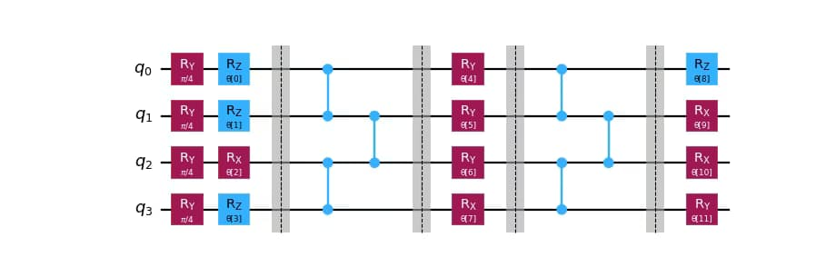
A typical PQC-based QNN consists of:
- Input Encoding Layer
Encodes classical data into quantum states using rotation gates.
- Parameterized Quantum Layers
Multiple layers of trainable rotations and entangling gates (analogous to hidden layers).
- Measurement Layer
Expectation values of observables serve as network outputs.
High-level flow:
[ x |(x) |(x,) y ]

4. Simple Math Involved
- Quantum state preparation: [ |(x,)= U() U_{}(x) |0 ]
- Model output: [ f(x,) = (x,) | O | (x,) ]
- Training objective: [ __i L(y_i, f(x_i,)) ]
where (L) is a classical loss function (e.g., mean squared error or cross-entropy).

5. Python Code (Quantum Neural Network – Algorithm)
Platform-agnostic execution code suitable for learning platforms
import numpy as np
from qiskit.circuit import QuantumCircuit
from qiskit.circuit.library import ZZFeatureMap, RealAmplitudes
from qiskit.primitives import Sampler
from qiskit_machine_learning.neural_networks import SamplerQNN
from qiskit_machine_learning.algorithms.classifiers import NeuralNetworkClassifier
from qiskit_machine_learning.optimizers import COBYLA
X_train = np.array([
[0.1, 0.2],
[0.2, 0.1],
[0.8, 0.9],
[0.9, 0.8]
])
y_train = np.array([0, 0, 1, 1])
num_qubits = 2
feature_map = ZZFeatureMap(num_qubits, reps=1)
ansatz = RealAmplitudes(num_qubits, reps=2)
qc = QuantumCircuit(num_qubits)
qc.compose(feature_map, inplace=True)
qc.compose(ansatz, inplace=True)
sampler = Sampler()
qnn = SamplerQNN(
circuit=qc,
sampler=sampler,
input_params=feature_map.parameters,
weight_params=ansatz.parameters,
)
optimizer = COBYLA(maxiter=100)
classifier = NeuralNetworkClassifier(
neural_network=qnn,
optimizer=optimizer
)
classifier.fit(X_train, y_train)
X_test = np.array([
[0.05, 0.1],
[0.85, 0.9]
])
predictions = classifier.predict(X_test)
print("Predicted labels:", predictions)

6. Where the Algorithm Is Useful
- Research on quantum-enhanced learning models
- Small-scale classification and regression problems
- Studying expressivity of quantum circuits
- Hybrid quantum–classical ML systems

7. Limitations
- No proven quantum advantage
- Training can suffer from barren plateaus
- Sensitive to noise
- Limited scalability on current hardware
- Requires careful circuit and optimizer design

8. Comparison with Classical Neural Networks
- Model: Classical NNs use weighted sums; QNNs use quantum amplitudes
- Training: Classical backpropagation vs. hybrid optimization
- Expressivity: QNNs may represent complex functions with fewer parameters
- Maturity: Classical NNs are highly optimized; QNNs are experimental

9. One-Sentence Summary
Quantum Neural Networks use parameterized quantum circuits as trainable models, optimized via hybrid quantum–classical learning loops to perform machine learning tasks.

